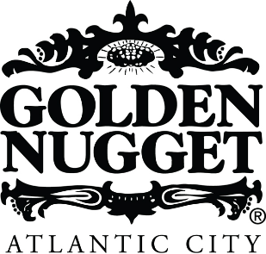
Media Contacts:
Mattie Van Gundy, mattie@dpwpr.com
Dancie Perugini Ware Public Relations
713.224.9115

MEDIA ADVISORY
TUESDAY, DECEMBER 31

DOUBLE THE FUN, DOUBLE THE NEW YEAR’S EVE PARTIES AT
GOLDEN NUGGET ATLANTIC CITY

WHAT: Golden Nugget Atlantic City is waving goodbye to 2019 and saying hello to 2020 this New Year’s Eve with two New Year’s Eve Parties on Tuesday, December 31.

Golden Nugget Atlantic City will host the New Year’s Eve 2020 Atrium Party. Free for guests to attend, the lively party will begin at 5:30 p.m. in the Main Atrium with live entertainment from Bobby & Kit and continue with DJ Wirez at 10 p.m. Partygoers can countdown to 2020 with an epic confetti drop at midnight.

Additionally, The Wave will host a New Year’s Eve Party beginning at 8 p.m. During the party, guests enjoy a 4-hour open bar from 8 p.m. – midnight while rocking out to live entertainment from Seven Stone. Guests will receive New Year’s Eve Party favors. The cost of admission is $75; however, discounted tickets will be available beginning Friday, November 29 using the promo code CYBER. Guests will receive 25% off through Cyber Monday.

WHEN: Tuesday, December 31

WHERE: Golden Nugget Atlantic City
Huron Avenue & Brigantine Boulevard
Atlantic City, NJ 08401
MORE
INFO: For additional information, please visit https://www.goldennugget.com/atlantic-city/entertainment/upcoming-events/nye-free-parties/, https://www.goldennugget.com/atlantic-city/entertainment/upcoming-events/new-years-eve-party/, https://www.facebook.com/goldennuggetac or call (609) 441-2000.

